**PHONE BOOK APPLICATION**

**Contents**

1.Project definition and scope

1.1 definition

1.2 scope

2.Preliminary Design

2.1 Use case

2.2 specification of use cases

3.Data Dictionary

3.1 Table: Login

3.2 Table: Category

3.3 Table: Contact

4.Output Pictures

**1.Project Definition and Scope**

**Definition:**

A book that lists the names, phone numbers of the people and businesses in a certain area

**Scope:**

Creating an End-to-End Application which is used to manage the contacts of people. This application has following features

1. Adding new contact
2. Deleting existing contact
3. Updating an existing contact
4. Displaying all the contacts
5. Get All Categories
6. Add categories
7. Delete categories
8. Update categories

**2.Preliminary Design:**

* This phone book application is using ASP.NET WEB API service to fetch and manipulate records of contacts in database.
* Database layer is developed for all the CRUD operations.
* Whole application follows n-tier architecture .
* All the forms are validated with client-side validations with proper error messages.
* Database used in MS SQL Server. following fields are used for contact table

Contact Id ----------------------->int

First Name----------------->varchar

Last Name----------------->varchar

Gender---------------------->Varchar

Contact Number-------------->Varchar

Email Id-------------------------->varchar

City------------------------------->varchar

State------------------------------->varchar

Country------------------------------->varchar

Picture--------------------------->varchar

**2.1Project Design:(use case diagram)**

The use case diagram is usually referred to as behavior diagram used to describe the actions of all users in a system

All user describe in use case are actors and the functionality as action of system

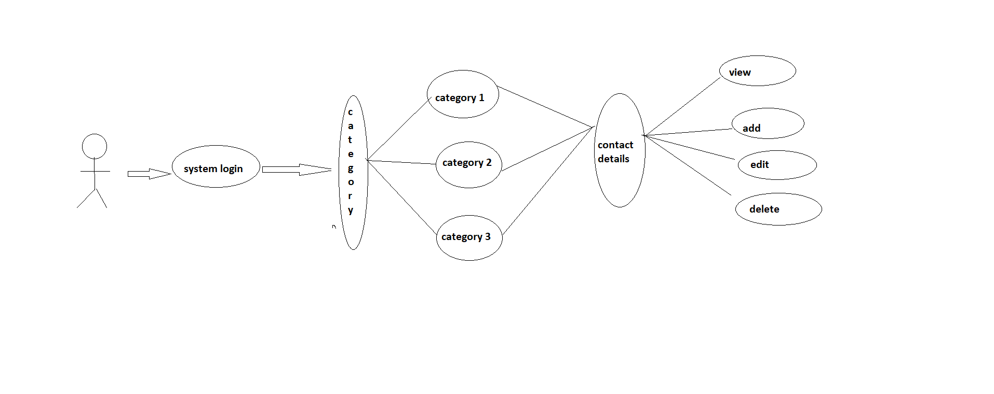

**2.2Specification of Use Cases:**

**Use case: Get All Contacts**

|  |  |
| --- | --- |
| **Element** | **Details** |
|  |  |
| **Person** | Admin |
| **Trigger** | Contact Details needs to be displayed |
| **Pre conditions** | Clicks on view details |
| **Post Conditions** | Contact Details will be displayed |
| **Process** | 1.Admin logins  2.view category details will be displayed  3.Admin click the category in which she wants to see contact details  4.Contact details will be displayed |

**Use case: Add contact**

|  |  |
| --- | --- |
| **Element** | **Details** |
|  |  |
| **Person** | Admin |
| **Trigger** | New Contact Details needs to be added |
| **Pre conditions** | Contact details were not present |
| **Post Conditions** | New Contacts were added and contact id will be auto generated |
| **Process** | 1.Admin click add new contact after login  2.Empty add contact form will be displayed  3.Admin will fill all the details of the new contact  4.validation of all fields are to be done  5.details has to be submitted to server  6.message will be displayed “contact added successfully” |

**Use case: Edit Contact**

|  |  |
| --- | --- |
| **Element** | **Details** |
|  |  |
| **Person** | Admin |
|  |  |
| **Trigger** | Admin wants to modify the contact details |
| **Pre conditions** | Contact details already existing in database |
| **Post Conditions** | Existing contact will get updated to new one |
| **Process** | 1.Admin click add new contact after login  2.Admin modifies the contact  3.validation of all fields are to be done  4.Existing contact will be updated to new one  5.message will be displayed “contact updated successfully” |

**Use case: Delete Contact**

|  |  |
| --- | --- |
| **Element** | **Details** |
|  |  |
| **Person** | Admin |
| **Trigger** | Admin wants to delete the contact details |
| **Pre conditions** | Contact details are shown in database and a message will be displayed “are you sure you want to delete the contact?” |
| **Post Conditions** | Contact deleted successfully |
| **Process** | 1.Admin clicks login  2.Admin selects the contact which he wants to delete  3.A message will be displayed “are you sure you want to delete the contact?”  4.Contact will be deleted  5.message will be displayed “contact deleted permanently” |

**Use case: Get All Categories**

|  |  |
| --- | --- |
| **Element** | **Details** |
|  |  |
| **Person** | Admin |
| **Trigger** | Category Details needs to be displayed |
| **Pre conditions** | Clicks on view Category details |
| **Post Conditions** | Category Details will be displayed |
| **Process** | 1.Admin logins  2.view category details will be displayed  3.Category details will be displayed |

**Use case: Add Category**

|  |  |
| --- | --- |
| **Element** | **Details** |
|  |  |
| **Person** | Admin |
| **Trigger** | New Category Details needs to be added |
| **Pre conditions** | Category details were not present |
| **Post Conditions** | New Categories were added |
| **Process** | 1.Admin click add new category after login  2.Empty add category form will be displayed  3.Admin will fill all the details of the new category  4.validation of all fields are to be done  5.details has to be submitted to server  6.message will be displayed “category added successfully” |

**Use case: Edit Category**

|  |  |
| --- | --- |
| **Element** | **Details** |
|  |  |
| **Person** | Admin |
|  |  |
| **Trigger** | Admin wants to modify the category details |
| **Pre conditions** | Category details already existing in database |
| **Post Conditions** | Existing category will get updated to new one |
| **Process** | 1.Admin click add new category after login  2.Admin modifies the category  3.validation of all fields are to be done  4.Existing category will be updated to new one  5.message will be displayed “category updated successfully” |

**Use case: Delete Category**

|  |  |
| --- | --- |
| **Element** | **Details** |
|  |  |
| **Person** | Admin |
| **Trigger** | Admin wants to delete the category |
| **Pre conditions** | Category details are shown in database and a message will be displayed “are you sure you want to delete the category?” |
| **Post Conditions** | Category deleted successfully |
| **Process** | 1.Admin clicks login  2.Admin selects the category which he wants to delete  3.A message will be displayed “are you sure you want to delete the category?”  4.Category will be deleted  5.message will be displayed “category deleted permanently” |

**3.DATA DICTIONARY:**

**3.1: login table**

**ADMIN USER:**

|  |  |  |
| --- | --- | --- |
| **FIELD NAME** | **TYPE** | **NOTE** |
| User Name | Varchar (50) | Login username |
| Password | Varchar (50) | Login password |

**3.3 Category table**

|  |  |
| --- | --- |
| **FIELD NAME** | **TYPE** |
| Category Id | int |
| Category Name | Varchar (50) |

**3.2: Contact Table**

|  |  |
| --- | --- |
| **FIELD NAME** | **TYPE** |
| ContactId | int |
| Category Id | int |
| FirstName | Varchar (50) |
| LastName | Varchar (50) |
| Gender | Varchar (50) |
| Contact Number | int |
| Email Id | Varchar (50) |
| City | Varchar (50) |
| State | Varchar (50) |
| Country | Varchar (50) |
| Picture | Varchar (50) |

**4.Output Pictures**

